**Intelligence Gathering Ships (AGI)**: The Soviet Navy uses intelligence gathering ships (*SSV* ***S****udno* ***SV****yazyy –* Communications Vessel) extensively around the world to gather electronic signatures on NATO and other ships, aircraft and land facilities. Most of the smaller ships were converted ocean going trawlers and they would often shadow NATO task forces, but could not keep up if evasive measures were taken. The larger ships would be at sea for considerable periods of time collecting and transmitting intelligence back to the Soviet Union for analysis.

**Libau Class, Project 357**: Communications Ship, and Training ship – 292 tons, 18 ships built in the 1950’s, about half in reserve.

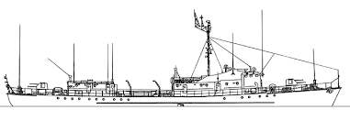

**Mirnyy Class, Project 393A**: Small Intelligence ship – 1,280 tons, 4 built (Vertikal, Val, Lotsman, Bakan)

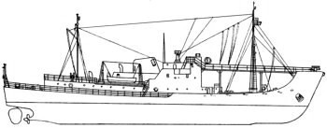

[**Primor’ye Class Project 394B, 994**](https://www.cia.gov/library/readingroom/docs/CIA-RDP85T00840R000100200001-5.pdf): Large Intelligence Ships – 4,260 tons, 4+2 built (Primor'ye, Krym, Kavkaz, Zabaykal`ye, Zaporozh`ye, Zakarpat`ye)

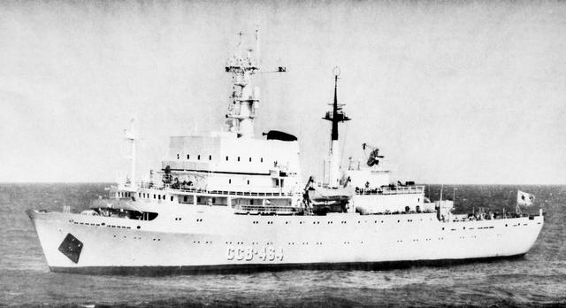

[**Mayak Conversions Project 502**](http://soviet-trawler.narod.ru/pages/ussr/foto_mayak_rzk.html): Small Intelligence Ships – 900 Tons, at least 26 built; however, some were used as Border Patrol, some as ASW and some as Refrigerated transport ships. The most important ship of this class for Northern Fury is the SSV Kursograf which starts the war just outside New York City harbor.

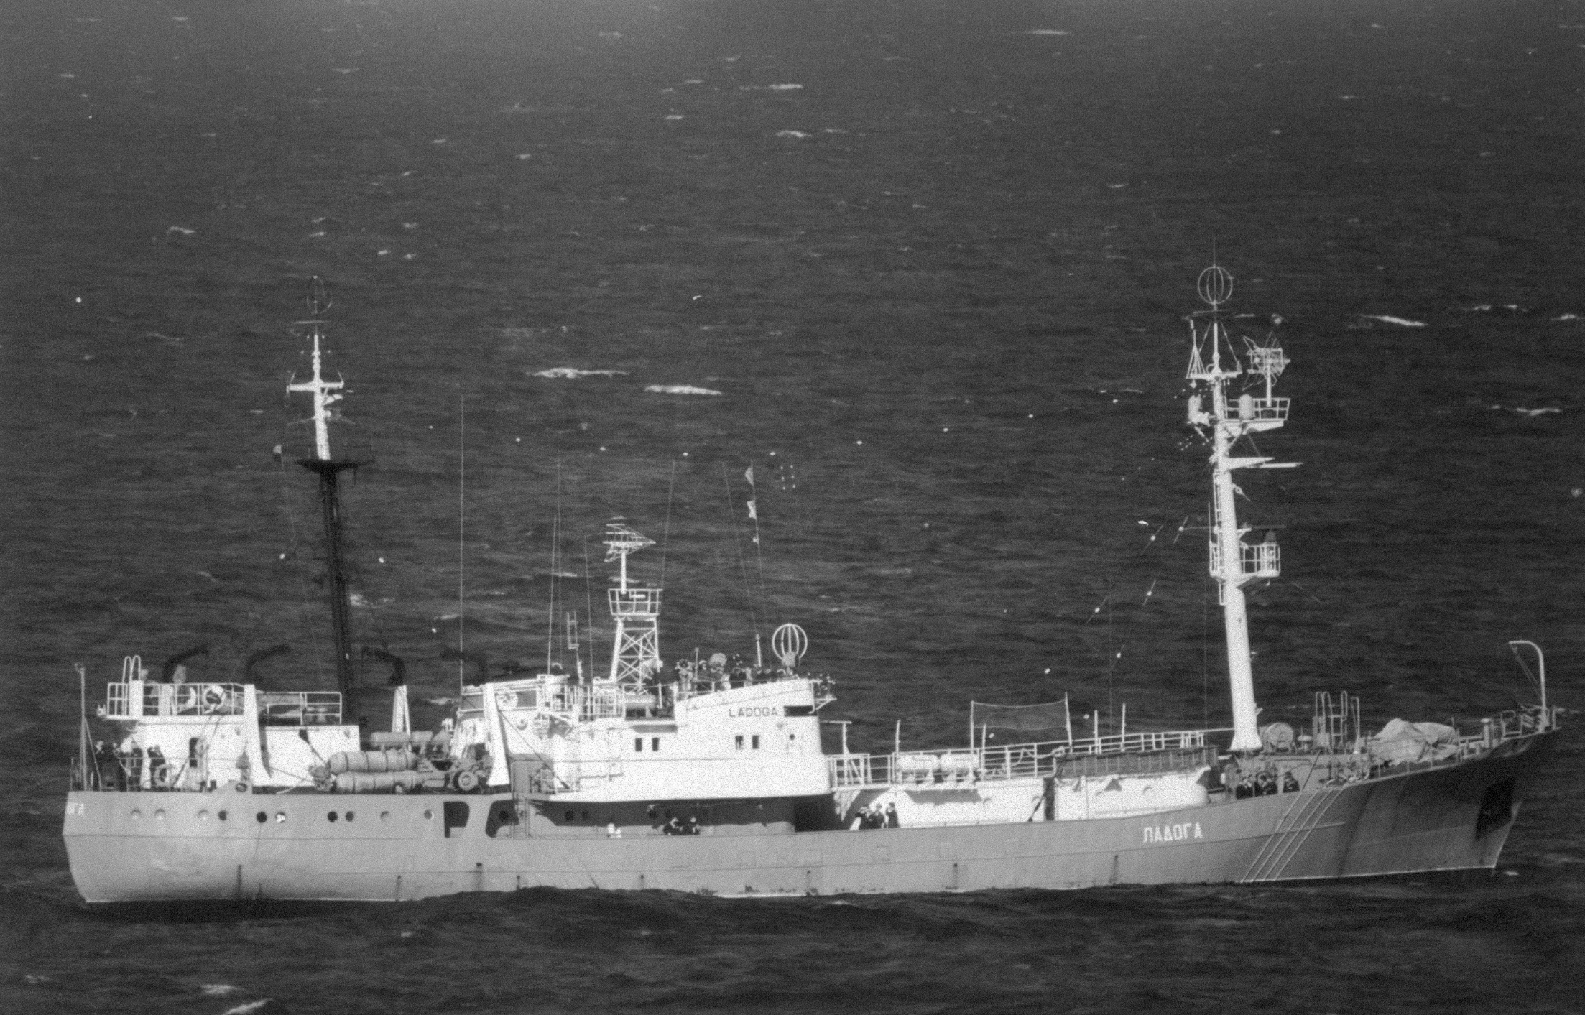

**Alpinist Class Project 503**: Medium Intelligence Ships – 1,140 tons, 15 ships built but 4 were AGI, while the remainder filled ASW, Border Guard and other roles. (GS-7, 8, 19, 39)

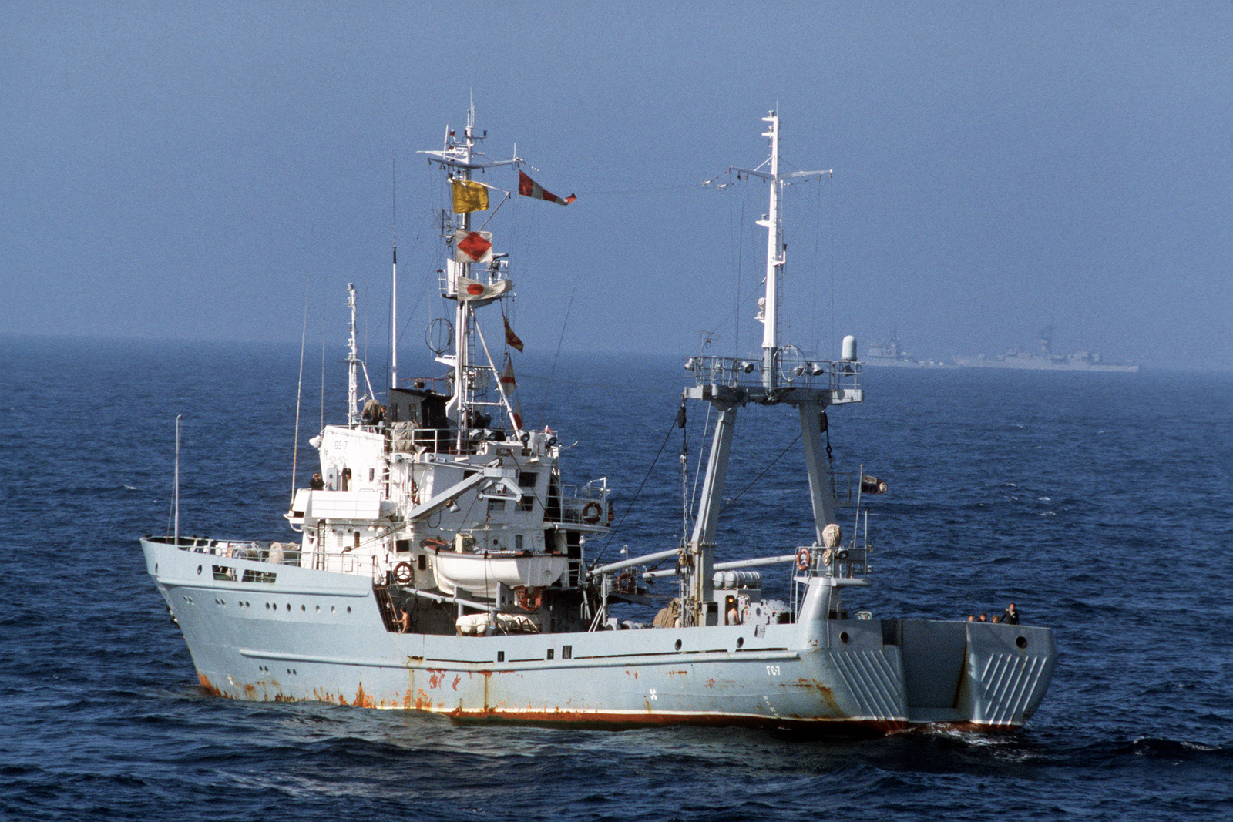

[**Vishnya Class, Project 864**](https://en.wikipedia.org/wiki/Vishnya-class_intelligence_ship): These medium sized ships are purpose built in the late 1980s as opposed to converted trawlers and specialize in gathering signals intelligence and transmit it back to the Soviet Union via satellite link. They are 3,470 tons, armed with point defence weapons and 7 were built.

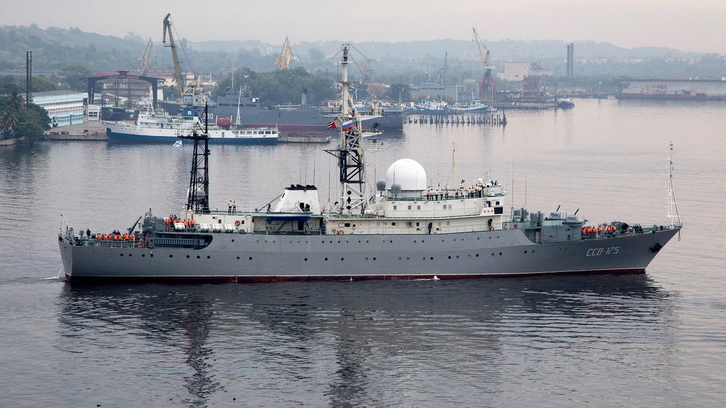

[**Balzam Class, Project 1826**](https://en.wikipedia.org/wiki/Balzam-class_intelligence_ship): These large intelligence ships were purpose built to gather signals and communications intelligence and transmit it back to the Soviet Union. They are armed with point defence and surface to air missiles (SAM). They are 4,900 tons and 4 of them were built.

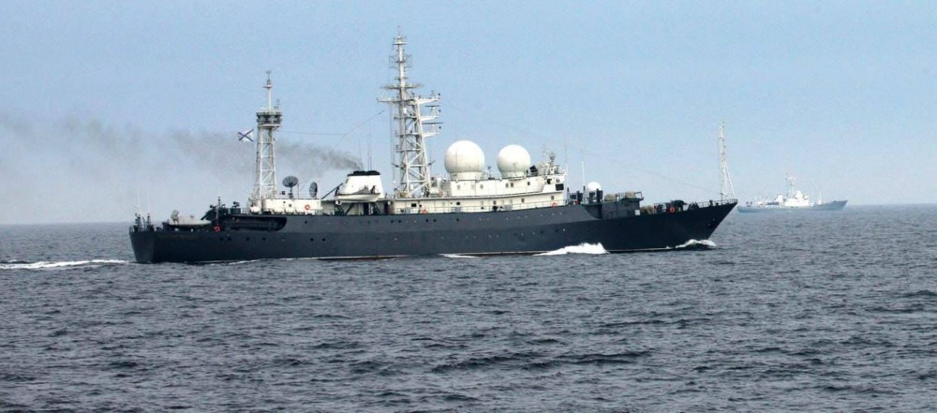

[**Kapusta Class, Project 1941**](https://en.wikipedia.org/wiki/Soviet_communications_ship_SSV-33): This single ship – *SSV-33 Ural,* (a second was cancelled) class was built on the same hull and with the same nuclear propulsion system as the Kirov Class Battle Cruisers and was extremely expensive to operate. At 36,500 tons she is a massive ship and capable of gathering communications, signals intelligence, track space objects and missiles as well as act as a communications relay station. He is armed with light defensive guns and SAMs.

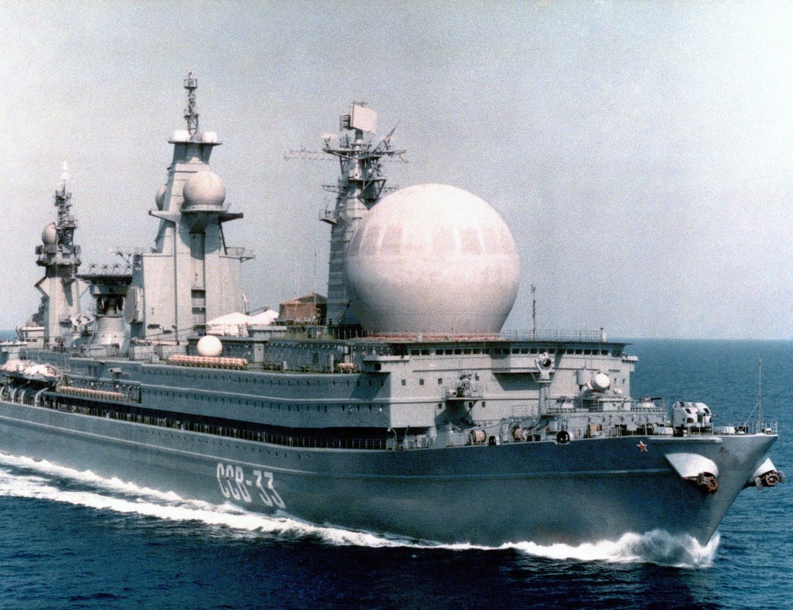

**Kamchatka Class, Project 12884**: Large Intelligence ship, a second ship of this class has advanced sonars and is used as a Submarine Search Ship. This ship is 5,830 tons and is able to gather both signals and communications intelligence.

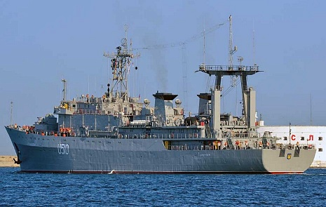

**Okean Class**: Small Intelligence ships – 725 tons, 15 built in East Germany, 9 in reserve, 6 active.

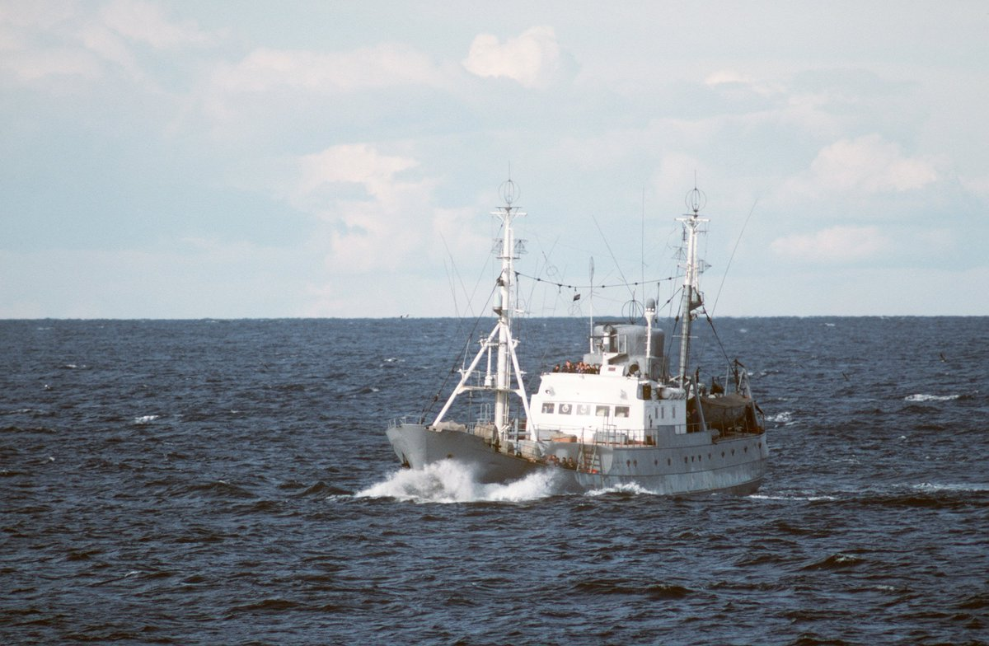

|  |  |  |  |
| --- | --- | --- | --- |
| **Major units listed only** | | | |
| Class | Name | Fleet | Status |
| Mirnyy | Vertikal | Black Sea |  |
|  | Val | Black Sea |  |
|  | Lotsman | Black Sea |  |
|  | Bakan | Black Sea |  |
| Primor’ye (Pr 394B) | Primor'ye | Pacific |  |
|  | Krym | Black Sea |  |
|  | Kavkaz | Black Sea |  |
|  | Zabaykal`ye | Pacific |  |
| (Pr 994) | Zaporozh`ye | Northern |  |
|  | Zakarpat`ye | Northern |  |
| Alpinist | GS-7 | Pacific |  |
|  | GS-8 | Pacific |  |
|  | GS-19 | Baltic |  |
|  | GS-39 | Baltic |  |
| Vishnya | Meridian | Baltic |  |
|  | Kareliya | Pacific |  |
|  | Tavriya | Northern |  |
|  | Priazov`e | Black Sea |  |
|  | Kurily | Pacific |  |
|  | Pelengator | Baltic |  |
|  | Odograf | Black Sea |  |
| Balzam | Lira | Northern |  |
|  | Aziya | Pacific |  |
|  | Pribaltika | Pacific |  |
|  | Belomor`ye | Northern |  |
| Kapusta | Ural | Pacific |  |
| Kamchatka | Pridneprovye | Pacific |  |
| Okean | Barometr | Black Sea |  |
|  | Ekholot | Northern |  |
|  | Krenometr | Northern | Reserve |
|  | Teodolit | Northern | Reserve |
|  | Repiter | Northern | Reserve |
|  | Traverz | Northern | Reserve |
|  | Lotlin` | Baltic |  |
|  | Reduktor | Baltic |  |
|  | Deflektor | Northern | Reserve |
|  | Linza | Baltic | Reserve |
|  | Gidrofon | Pacific | Reserve |
|  | Ampermetr | Pacific | Reserve |
|  | Alidada | Black Sea |  |
|  | Barograf | Pacific | Reserve |
|  | Zond | Baltic |  |